**Experiment: 1**

**Aim:** Input two numbers and prints its square and cube.

**Software:** Dev C++

**Code:**

**#include<stdio.h>**

**double** cube**(int** a**)**

**{**

**double** cube_ans**;**

**cube_ans=**a*a*a**;**

**return** cube_ans**;**

**}**

**double** square**(int b)**

**{**

**double** square_ans**;**

**square_ans=** b*b**;**

**return** square_ans**;**

**}**

**int main()**

**{**

**double** num1,num2**;**

**printf("**Enter The Number-1:-**");**

**scanf("%lf",&**num1**);**

**printf("**Enter The Number-2:**-");**

**scanf("%lf",&**num2**);**

**printf("**The Square Of Number-1 Is %.2lf**\n",square(num1));**

**printf("**The Square Of Number-2 Is %.2lf**\n",square(num2));**

**printf("**The Cube Of Number-1 Is %.2lf**\n",cube(num1));**

**printf("**The Cube Of Number-1 Is %.2lf**\n",cube(num2));**

return **0;**

**}**

**Output:**

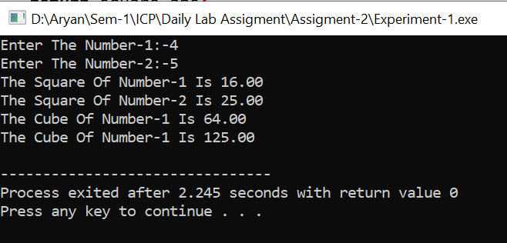

**Experiment: 2**

**Aim:** Verify the formula x=((k-4)*(a*4))/100

**Software:** Dev C++

**Code:**

**#include<stdio.h>**

**int** main**()**

**{**

**int** k,a;

**float** x;

**printf("**Enter the Value of A:-");

**scanf("%d",**&a**);**

**printf("**Enter the Value of K:-");

**scanf("%d",**&k**);**

**x**=(((k-4)*(a*4))/100**);**

**printf("**The Value Of X Is **%f",x);**

return **0;**

**}**

**Output:**

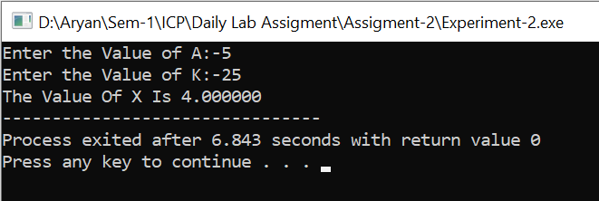

**Experiment: 3**

**Aim:**  Calculate the area of Triangle.

**Software:** Dev C++

**Code:-**

**#include<stdio.h>**

**int** main**()**

**{**

**double** base,height,area**;**

**printf("**Enter The Height Of Triangle:-**");**

**scanf("%lf",&**height**);**

**printf("**Enter The Base Of Triangle:-**");**

**scanf("%lf",&**base**);**

**area=**0.5*base*height**;**

**printf("**The Area OF Triangle Is **%.2lf sqm",**area**);**

return **0;**

**}**

**Output:**

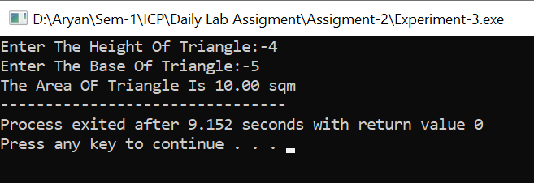

**Experiment: 4**

**Aim:**  Input two numbers and prints its Addition, Subtraction, Multiplication, and division.

**Software:** Dev C++

**Code:-**

**#include<stdio.h>**

**int** main**()**

**{**

**int** a,b**;**

**printf("**Enter A Number-1:-**");**

**scanf("%d",**&a**);**

**printf("**Enter A Number-2:-**");**

**scanf("%d",**&b**);**

**printf("**Addition Is **%d\n",a+b);**

**printf("**Substraction Is **%d\n",a-b);**

**printf("**Multiplication Is **%d\n",a*b);**

**printf("**Division Is **%d",a/b);**

return **0;**

**}**

**Output:-**

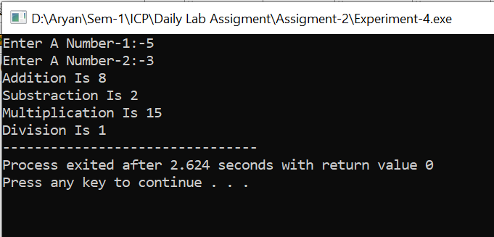

**Experiment: 5**

**Aim:-**  Input a Number of Chairs and its Total Cost and Prints the Cost of Each chair

**Software:-** Dev C++

**Code:-**

**#include<stdio.h>**

**int** main**()**

**{**

**double** num,cost**;**

**printf("**Enter The Number Of Chairs:-**");**

**scanf("%lf",&**num**);**

**printf("**Enter The Total Cost:-**");**

**scanf("%lf",&**cost**);**

**printf("**The Cost Of One Chair Is **%.2f",**cost/num**);**

return **0;**

**}**

**Output:-**

